**Caribou**

**De HAVILLAND CANADA DHC-4 CARIBOU A4-225**

Twin-engined Light Tactical Transport

**History of A4-225**

This Caribou was accepted by the RAAF from De Havilland Canada in June 1965 and assigned the RAF serial A4-225. It was allocated to 38 Squadron at RAAF Richmond in June 1965 and served in New Guinea with Detachment ‘A’ between 1965 and 1971, where it was used to qualify crews in tropical and difficult terrain conditions before deployment to Vietnam. During its time in New Guinea this aircraft discovered the wreck of an RAAF Dakota missing since 1945. It participated natural disaster relief work, including Cyclone Althea relief operations in Townsville in December 1971. A4-225 continued in service with 38 SQDN at Richmond and Amberley until its retirement in 2009 and was placed in open storage at Oakey, Queensland.

SAAM acquired A4-225 by tender from Commonwealth Department of Defence Disposals. The aircraft was dismantled by SAAM volunteers at Oakey and the wings, engines propellers and tail unit arrived at SAAM on 17 June 2016. The fuselage was transported separately by low loader via the Strzelecki Track due to NSW width restrictions, departing Oakey 27July and arriving at SAAM on 7 August. Once our new hangar was completed, the Caribou was re-assembled and is now on display with the rear ramp lowered allowing access to the interior.

 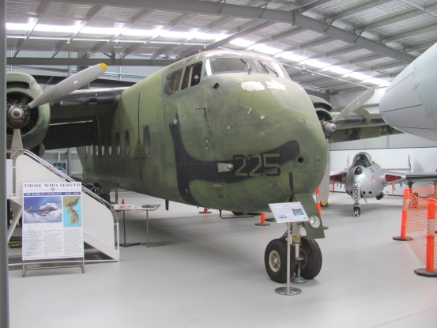

**History of Type**

The Caribou is a light tactical transport with rear-opening ramp doors for rapid loading and unloading. The prototype Caribou first flew on 30 July 1958. The RAAF acquired a total of 29 Caribous in several batches over a number of years to replace the venerable Dakota. The first six were delivered directly to the RAAF Transport Flight Vietnam in 1964 following the commitment by the Australian Government to provide transport aircraft to Vietnam. The Caribou subsequently served in Vietnam until February 1972 carrying a total of 700,000 passengers and 41,300 tonnes of freight over 47,000 flying hours, the Australian detachment being known as ‘Wallaby Airlines’.

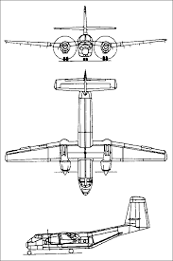The Caribou was used by the RAAF for the airlift of troops, civilians, supplies ammunition, mail and food, as well as for medical evacuation, search and rescue and paratroop training. Caribous also operated in New Guinea, flew daily mercy flights (in Red Cross markings) to refugees in East Timor from Darwin in 1975 and also operated with the UN Military Observer Group along the India-Pakistan border.

In 1991, it was announced that the Caribou fleet would be reduced to 14 aircraft pending acquisition of a suitable replacement aircraft, with retired aircraft placed into storage to provide a spares stock for the remaining aircraft. The replacement of the Caribou was a long drawn out process, with the remainder of the fleet being retired in 2009 with no final decision made. Initially Beechcraft King Airs were acquired to partially replace the Caribou and it was not until 2012 that the C-27 Spartan was chosen to provide a battlefield transport capability for the RAAF, initial deliveries commencing in 2015.

The U.S. Army was the largest operator of Caribous, with close to 160 of a total of 307 Caribous built.

**Technical Specifications**

**Engine :** 2 x Pratt & Whitney R2000 radial engines of 1450hp driving 3 blade propellers

**Maximum Take-off Weight :** 12,927Kg

**Length :** 22.13m

**Wingspan :** 29.15m

**Height :** 9.68m

**Cruising Speed :** 293km/hr **Maximum Speed :** 348km/hr

**Ceiling :** 7560m

**Range :** 2100km (max)

**Crew :** 2 x pilots, 1 x loadmaster/engineer

**Capacity :** 32 troops or 26 paratroopers or up to 4 tonnes of cargo (e.g. 2 Land Rovers)