**Commanche**

**PIPER PA-24-250/A1 COMMANCHE S/N 24-13333 VH-DOL**

Four seat high performance light aircraft

**History of VH-DOL**

Piper Commanche VH-DOL was manufactured by Piper Aircraft Corporation in the United States in 1959 where it was registered as N6230P. It was first registered in Australia in 1962 in South Australia and remained there throughout its operational life.

VH-DOL competed in the 1969 London - Adelaide - Sydney BP Commemorative Air race flown by its owner, Rick Buchanan and Ian Britten-Jones, and placed second in class. The race commemorated the first flight from England to Australia in 1919 and the bicentenary of James Cook’s discovery of Australia’s east coast.

It was withdrawn from service in 1992 and was stored in a hangar for twenty-two years until it was donated to SAAM by Mr Buchanan’s son and daughter, arriving at the museum in December 2014. It is now on display in the main hangar.

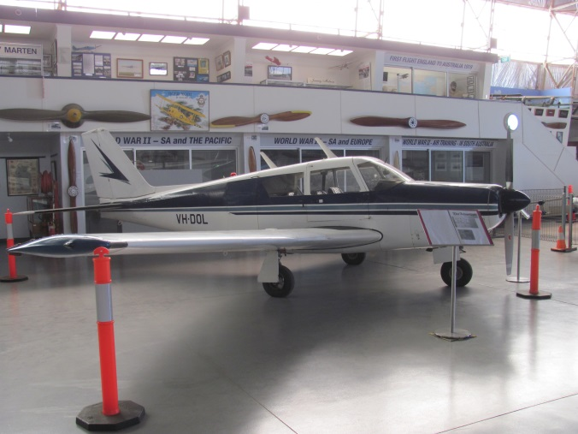

**History of Type**

The Piper Commanche was a high performance aircraft for its time, designed to rival the established market leader, the Beech Bonanza. It featured a retractable tricycle undercarriage, swept back fin and rudder, all-flying tailplane,low set laminar flow wing, and was of all metal construction, previous Piper aircraft having been high wing, fabric covered designs. The Commanche first flew in May 1956, with first deliveries of the initial PA-24-180 model with 180hp engine in late 1957.

Subsequent models included 250 and 400hp engines, followed by a turbocharged engine in 1970. When PA-24 production ended in June 1972 (due to flooding of the Piper plant) 4856 PA-24s had been produced.

**Technical Specifications**

**Engine :** 185kW (250hp) Lycoming O-540-A1A5 flat four piston engine driving 2 bladed

Hartzell propeller

**Maximum Take-off Weight :** 106kg

**Length :** 7.6m

**Wingspan :** 10.97m

**Height :** 2.3m

**Cruising Speed :** 283km/hr (153 knots)

**Ceiling :** 20,000ft

**Capacity :** Pilot and 3 passengers

**Range :** 1,800km