**Orion**

**LOCKHEED AP-3C ORION A9-756**

Maritime patrol, anti-submarine, anti-shipping surveillance aircraft

**History of A9-756**

In the tradition of Sunderland, Catalina, Lincoln and Neptune, the P-3 Orion first joined the RAAF in 1968. A9-756 Lockheed Constrn. No. 5666, USN Serial 160756) was delivered to 10 SQDN in September 1978 as a P-3C, and was the sixth aircraft for the RAAF of this variant. It undertook operational and training roles with 92 Wing in its 39 years of service. A9-756 was upgraded to AP-3C standard during the early 2000s. It was retired as part of the progressive withdrawal from service of the AP-3C to be replaced by the Boeing P-8 Poseidon.

A9-756 was acquired by SAAM through a tender process from Defence Disposals, with Deed of Transfer signed 23 October 2017. It was dismantled by Airbus Industries at RAAF Base Edinburgh and delivered in two tranches - 1) Engines, propellers, control surfaces, radomes etc on 23 November 2017 on six semi-trailers by the Army Combat Service Support Section 2) Fuselage, port wing and tailplane assembly on 10 December 2017 on 2 semi-trailers and utilising four cranes to move into our new Hangar 2 (due to space considerations, the starboard wing was not acquired).

Pending re-assembly the fuselage is currently on display in Hangar 2 on cradles. Once assembled it will be displayed close to the far wall of the hangar with under-carriage lowered and two engines and propellers installed, and a third engine displayed separately.

 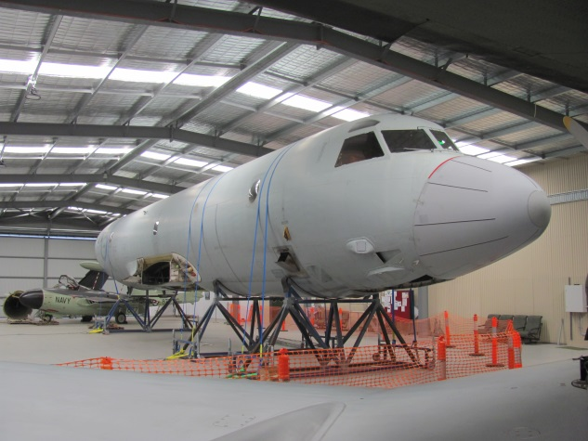

**History of Type**

The Lockheed P-3 Orion was developed from the civil L-188 Electra airliner as a replacement for the Lockheed Neptune maritime reconnaissance aircraft used by a number of nations (including Australia), the prototype flying for the first time in August 1958.The initial service variant, the P-3A, entered service in 1962 and an improved version, the P-3B, followed in 1965. The P-3C was a completely revised version with the entire electronics suite replaced by new computer controlled systems, the installation of cartridge fired tubes for sonobuoys under the rear fuselage, an IR system rather than searchlight for night surveillance, and hard points under the outer wing that could carry Harpoon missiles. Further updates (known as Update 1 and Update II) followed.

The Orion replaced the Neptune in Australian service with ten P-3Bs being ordered in 1964 to replace the older P2-V5 Neptunes of 11 SQDN, these being delivered progressively from January 1968 – 11 SQDN moved from Townsville to Edinburgh on receipt of their Orions. The remaining P2-V7 (later re-designated SP-2H) operated by 10 SQDN were replaced by P-3C Orions with an initial eight being ordered May 1975, and two more ordered in May 1976. The first of these was delivered in May 1978, at which time 10 SQDN also moved to Edinburgh. In 1980 it was decided to order ten more P-3Cs to replace the older P-3B rather than attempt to upgrade them. The P-3Bs were traded in on the new P-3Cs with some subsequently sold to Portugal and one to New Zealand.

With the addition of 292 (Training SQDN) 10 and 11 SQDNs became 92 Wing. Project Air 5276 saw the Orions upgraded to AP-3C standard with all aircraft upgraded by December 2004 – changes included upgrades to mission computer, tracking, navigation and radar systems with new cockpit displays. The AP-3C is a uniquely Australian variant.

The AP-3C is being progressively replaced by the Boeing P-8 Poseidon, with 11 SQDN having converted to the new aircraft, all remaining AP-3Cs (13 as at October 2017) now with 10 SQDN.

**Technical Specifications**

**Engine :** 4 x Allison T56-A-14 turboprop of 4600 shaft horsepower

**Maximum Take-off Weight :** 61,200kg

**Length :** 35.6m

**Wingspan :** 30.8m

**Height :** 10.44m

**Cruising Speed :** 650km/h cruise (at 26,000 feet), 370km/h loiter, 750 km/h maximum

**Ceiling :** 35,000 feet

**Range :** Ferry range 8945km, endurance 15 hours, mission radius 3 hours on station at

1,500 feet 2,500km

**Crew :** Pilot, Co-pilot, Flight Engineer(s), Tactical Commander, Navigator/Communications

Officer, Sensor Employment manager, up to six Airborne Electronic analysts

**Armament / Stores :**

Mk46 lightweight anti-submarine torpedoes

AGM-84 Harpoon anti-ship missiles

Sonobuoys

Maritime Marker Devices

Survivor Air Heliboxes

Self-protection Measures (flares, etc.)