Lockheed AP-3C Orion A9-756
Maritime patrol, anti-submarine, anti-shipping surveillance aircraft

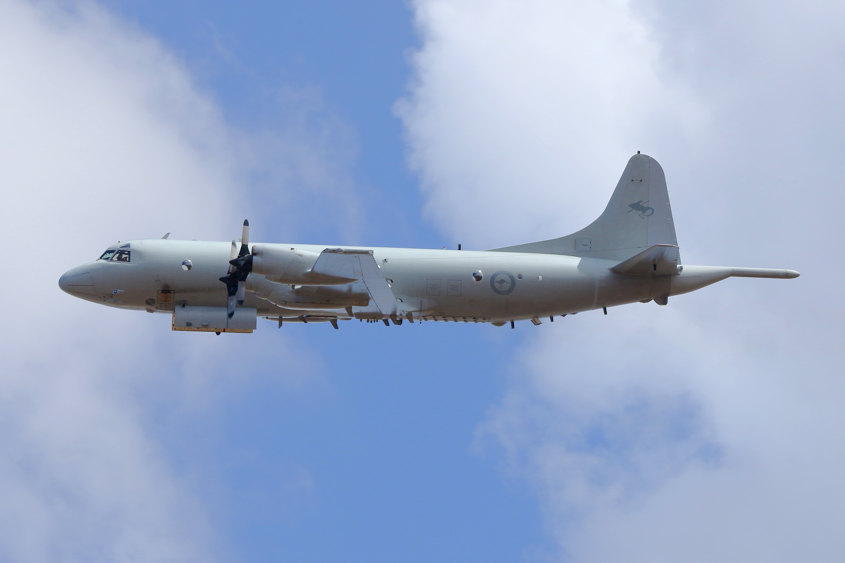

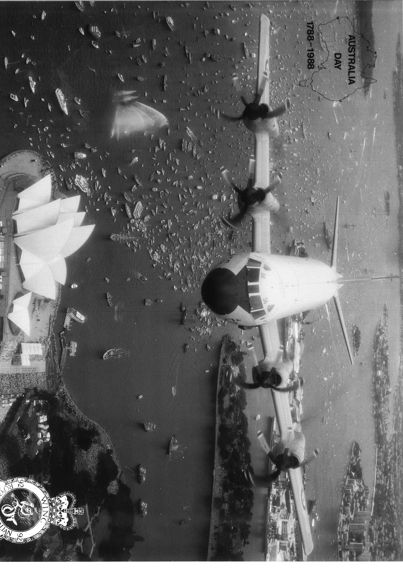

A9-756 was delivered to 10 Squadron RAAF in September 1978 as a P-3C and was the sixth aircraft for the RAAF of this variant. During its almost 16,000 hours of service it undertook operational duties in Asia and the SW Pacific as well as search and rescue missions. Search and Rescue missions included the following:
On 26 Mar 1980, it conducted a search for the livestock carrier FAHID FARES which was on fire and sinking 200 nautical miles south of Kangaroo Island. The crew of A9-756 located the vessel and coordinated with a Polish fishing vessel DENABOLA for the rescue of the crew of the stricken vessel.
In December 1998 it was one of the aircraft that assisted in the search and rescue of stricken yachts in the 1998 Sydney - Hobart yacht race.
In March 2014 it took part in the unsuccessful search for the missing Malaysian airline MH 370.

A9-756 was upgraded to AP-3C standard during the early 2000s. It was retired as part of the progressive withdrawal from service of the AP-3C which was replaced by the Boeing P-8 Poseidon.
A9-756 was acquired by the Museum through Defence Disposals in October 2017. It was dismantled by Airbus Industries at RAAF Base Edinburgh who had maintained the aircraft for the RAAF.
The Museum would like to acknowledge the sponsorship of 
in presenting this aircraft for display.



Technical Specifications
Engine : 4 x Allison T56-A-14 turboprop of 4600 shaft horsepower
Maximum Take-off Weight : 61,200kg
Length : 35.6m
Wingspan : 30.8m
Height : 10.44m
Cruising Speed : 650km/h cruise (at 26,000 feet), 370km/h loiter, 750 km/h maximum
Ceiling : 35,000 feet
Range : Ferry range 8945km, endurance 15 hours, mission radius 3 hours on station at
1,500 feet 2,500km
Crew : Pilot, Co-pilot, Flight Engineer(s), Tactical Commander, Navigator/Communications
Officer, Sensor Employment manager, up to six Airborne Electronic analysts
Armament / Stores :
Mk46 lightweight anti-submarine torpedoes
AGM-84 Harpoon anti-ship missiles
Sonobuoys
Maritime Marker Devices
Survivor Air Heliboxes
Self-protection Measures (flares, etc.)



