**Kavanagh Hot Air Balloon**

**KAVANAGH D-77 BALLOON S/No KB005 VH-HOV**

Hot Air Manned Free Balloon

**History of**

VH-HOV is a hot air manned free balloon – it was manufactured in April 1980 and was first registered as VH-HOV in March 1986. It was flown from 1980 to 2012 at many locations in SA and Victoria including Monarto, the Barossa and the Riverland. It was donated to SAAM by Ms Rosemary Hanson on 16 December 2014, and is currently in storage pending preparation of a suitable display area.



**History of Type**

Kavanagh have been making hot air balloons for 45 years, moving into the industry by chance after assisting the Sydney University Balloon Club in 1968 with transporting their balloons. His first balloon took to the air in 1969, and by 1979 he was in the balloon manufacturing industry full-time, making some 500 balloons over the years.

The baskets use South East Asian cane and the fabric for the canopy is from South Africa – a single canopy requires some 200sq m and consists of around 800 panels. There is also a gas burner and fuel tanks, a balloon takes around three months to make.

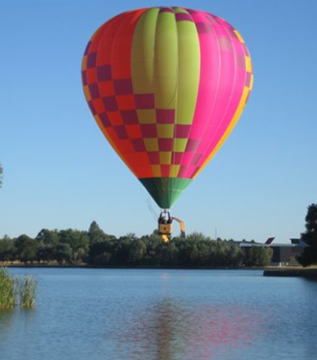**Technical Specifications**

**Engine :** Hot air burner

**Take-off Weight :** 294kg - basket / burners 76kg, 4 full gas bottles

134kg

**Envelope Capacity :** 2,190 cubic metres

**Capacity :** Pilot plus up to 3 passengers

**Crew :** 1 pilot