**Hall Cherokee II**

**HALL CHEROKEE II GLIDER VH-GPR**

Single seat glider

**History of VH_GPR**

The Cherokee II designed by Stan Hall was introduced in 1956 for amateur construction from plans. It has a wooden airframe covered with fabric. It was launched by either a winch or by a tow-plane.

VH-GPR was built by Robert Blunt from Deniliquin , NSW in 1966, and was last owned by Lloyd Stewart and flown operated from Lochiel in South Australia. It was kindly donated to SAAM by Lloyd and Hedley Stewart in mid-2011, and is displayed in the main hangar suspended from the roof above the Canberra.

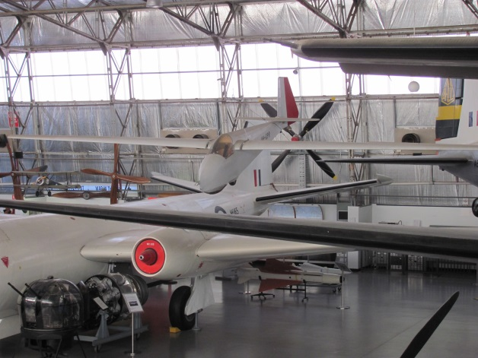

**History of Type**

The Hall Cherokee II is a high wing, single seat glider designed in the USA by Stan Hall, and was designed for construction from a set of plans. Its low cost and ease of construction made it a popular home-built glider.

The Cherokee II is of all-wood construction covered in doped fabric. It has a fixed single wheel undercarriage and has a dual spar wing with spoilers on top and removable outer wing panels for ease of ground transportation.

Around 100 were constructed in North America and Australia.

**Technical Specifications**

**Weight :** Empty 154kg, gross 240kg

**Length :** 3.6m

**Wingspan :** 12.2m

**Maximum Glide Ratio :** 23:1 at 74 km/h (46 mph)

**Crew :** 1 pilot