**SAAM Camera Pod (on loan from DSTO)**

Identifying Marks (located inside one of the access hatches):

Part E7003199 (Issue 4)

S/N 179 23/8/57 (also a Dec 1958 stamp)

Job Number: 300440/257

Also noted is the labeling of one of the electrical harnesses as ‘Camera’.

At a time before the development of real-time electronic data collection, high-speed cine cameras were required to record the behaviour and relative success of missiles to their intended targets. This pod was part of the WRE collection and is most likely an AMPOR (Airborne Missile Proximity Optical Recorder) **[1]** Camera Pod fitted to the Jindivik pilotless aircraft to aid in the testing of missiles and guided weapons (circa) 1958 **[2]**.

The tests were part of the ‘*Anglo-Australian Joint Project’*, which ran from 1946 to 1980. Testing of the missiles occurred at RAF Llanbedr in Wales and at Woomera. At Woomera, Meteors and Canberra Bombers were converted into target drones for early tests. By 1953, the Government Aircraft Factories (GAF) had begun the development of the Jindivik target drone, specifically designed for testing purposes. **[3]**

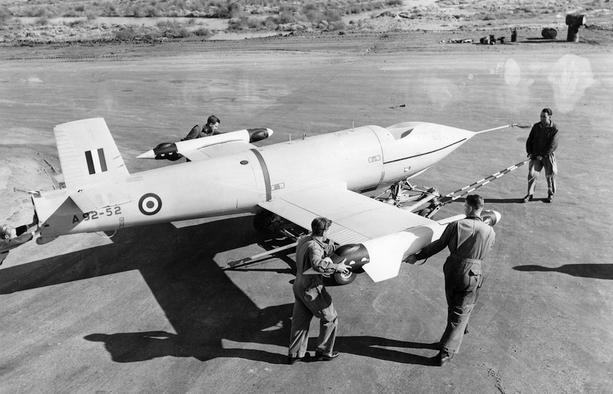

Jindivik A92-52 fitted with Camera Pods, at Woomera **[4]**

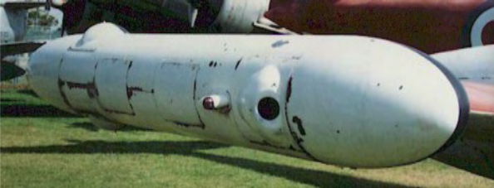

Mk 2 AMPOR Wing Tip Pod **[3]**

AMPOR Camera Pod Dimensions **[3]**

AMPOR Mk 1 Pod Aluminium Alloy 265cm Long 26.7cm Diam

AMPOR Mk 2 Pod Aluminium Alloy 220cm Long 38cm Diam

There were early tests of the Jindivik with Mk 1 AMPOR pods (circa 1955) but they were problematic and resulted in one Jindivik breaking up in flight. The Mk 2 Pod was used for a short time on the Jindivik but the performance was restricted. By 1957, the Mk 3 AMPOR Pods (2 WRETAR cameras and much smaller pods) were introduced and used alongside the older models. By 1959, the Mk 2 AMPOR Pods ceased being used.

**[1]**  AMPOR – Airborne Missile Proximity Optical Recorder

**[2]** Our pod has an identifying date of 1957 and a date stamp of 1958 located on the inside of one of the access hatches.

**[3]** Mk 2 AMPOR Wing Tip Pod Photograph

*Spennemann (2015) Target Aircraft Cameras GW1 & GW2 Report.pdf*

**[4]** Jindivik A92-52 fitted with Camera Pod, at Woomera

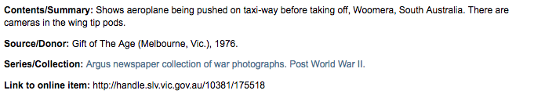State Library of Victoria Collection

Other Sources:

<http://www.ctie.monash.edu.au/hargrave/rpav_jindivik.html>

<http://search.slv.vic.gov.au/MAIN:Everything:SLV_VOYAGER1714821>