**Mirage**

**Dassault / Government Aircraft Factory Mirage IIID A3-115**

Two seat Operational Trainer

**History of Mirage IIID A3-115**

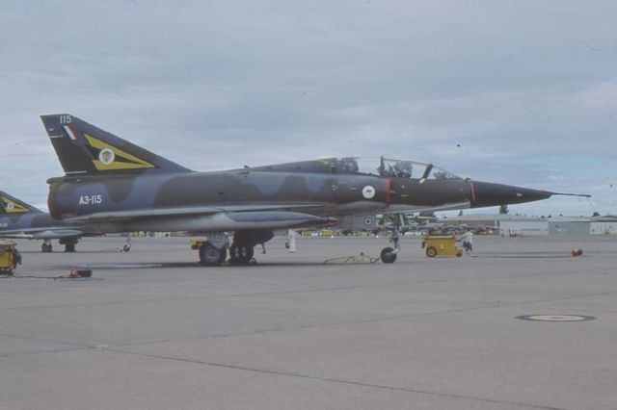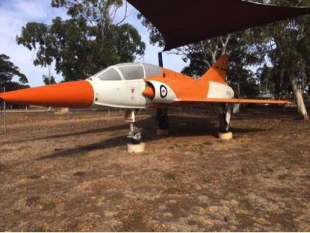

A3-115 is a two seat operational trainer variant of the Mirage IIIO interceptor, one of 16 delivered to the RAAF. It was delivered to the RAAF in December 1973, the second last of the Australian Mirages.

During its RAAF career A3-115 served with 2 Operational Conversion Unit (OCU) and with 77 Squadron at RAAF Willamstown, and also with the Aircraft Research and Development Unit (ARDU) at RAAF Edinburgh. It was withdrawn from RAAF service in December 1986 and stored until 1999 when it went back to ARDU to be restored in ARDU colours. It was subsequently displayed at airshows held at RAAF Edinburgh before being installed as a ‘gate guardian’ at RAAF Edinburgh.

A3-115 was gifted to SAAM by the RAAF in May 2018, and is on external display in the SAAM compound between Hangars 1 and 2.

**History of Type**

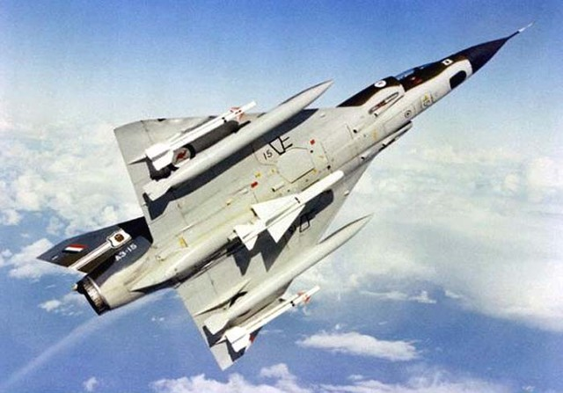

The Mirage III was acquired by the RAAF as a replacement for the CAC-27 Avon Sabre; the process of evaluation originally commenced in the late 1950s and aircraft considered included the Lockheed F-104G Starfighter, the Northrop N-156 (later to become the F-5 / T-38), the English Electric Lightning and the McDonnell F4H-1 Phantom II, with the Dassault Mirage III a late starter; the F-104 was a leading contender before the Mirage was selected in 1961. An initial contract for 30 single seat aircraft was signed in March 1961, with subsequent contracts in 1962 and 1963 increasing the order to 100 single seat and 10 dual seat aircraft, the latter increased to 16 in 1970 – a total of 116 Mirages. It was decided to construct the Mirage in Australia, with the Government Aircraft Factory being the prime contractor and the Commonwealth Aircraft Corporation being the major sub-contractor, building the wings, fin and engine.

The single seat interceptor version was designated Mirage IIIO and the two seat operational trainer version designated Mirage IID. The first two Mirages were constructed in France, and Australian content progressively increased with A3-16 being the first all Australian aircraft. All of the two seaters had French built fuselages.

There were two variants of the single seat aircraft – the Mirage IIIO(F) interceptor and the Mirage IIIO(A) with ground attack capability, the latter having Doppler attack navigation equipment (subsequently retro-fitted to the earlier IIIO(F) variants). Both versions were armed with two 30mm DEFA cannon and Sidewinder or Matra 550 air to air missiles (SAAM has an example of a Matra missile on display); bombs or drop tanks could also be carried.

The Mirage entered service with 75 Squadron in 1965, and subsequently served with five RAAF squadrons (3, 75, 76, 77 and 79) based at Williamstown, Darwin and Butterworth, Malaysia) from 1965 to 1989, the last RAAF Mirage flight being in February 1989.

The two-seat Mirage IID served with 2OCU and also with each operational squadron.

During its RAAF career, 40 Mirages were lost in accidents. After retirement from the RAAF, remaining Mirages were stored until 50 were sold to the Pakistan Air Force in 1990, the rest being allocated to Museums or scrapped.

**Technical Specifications**

**Engine :** 1 x SNECMA Atar 9c axial flow turbojet with 9 stage compressor rated at 9,430lb

thrust at 8,400rpm, and 1,670lb thrust at 8,400rpm with afterburner.

**Maximum Take-off Weight :** 13,700kg (30,200lb); 7,050kg (15,540lb) empty

**Length (single seat) :** 15.03m

**Wingspan :** 8.22m

**Height :** 4.5m

**Speed (single seat) :** Maximum level speed Mach 2.2 (2,350km/h 1,460mph)

Cruise Mach 0.9 (958km/h 595mph)

**Ceiling :** 19,995m (55,755ft) at Mach 1.8

**Range :** Combat radius 1,200km (745 miles), maximum ferry range 3,860km (2,400 miles)

**Crew :** 1 pilot (single seat) ; 1 pilot and 1 instructor (two seat)

**Armament** : 2 x 30mm DEFA cannon with 125rpg; maximum load of 3,990 ordnance on

4 under wing and single fuselage hard points – 1 x Matra R.530 or R.550 Magic heat seeking air to air missiles under the fuselage and/or 2 x AIM-9B Sidewinder air to air missiles under wings

