**Cessna CC-1**

**CESSNA CC-1**

Replica aircraft commemorating the first aircraft to fly in South Australia

**History of Cessna CC-1**

The Cessna CC-1 on display in the main hangar is a replica of Clyde Cessna’s original aircraft which was built in 1911. It is similar to the Bleriot which was the first aircraft to fly in South Australia. The Cessna replica is fitted with a replica three cylinder Anzani engine, which also powered the Bleriot.

The replica was built by Rossair in 1966, and after being displayed in Rossair’s sales department, was stored in a shed at Gawler for forty years. It was donated to the museum by the family of Gordon Lewis.

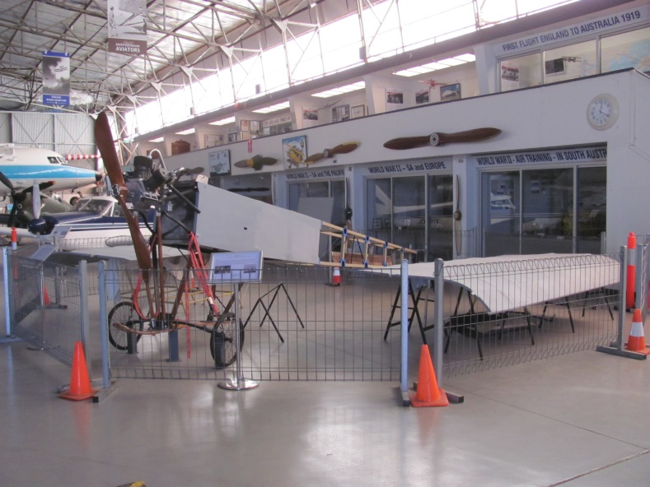

**History of Type**

Clyde Cessna built his aeroplane in May 1911 and based the design on the Bleriot XI monoplane. It was powered by a 60hp Anzani engine and could fly at up to 90mph.

Rossair Aviation of Parafield constructed a full scale replica of Cessna’s aeroplane for display purposes. They installed a 25 hp Anzani engine which had originally been installed in the Bleriot aircraft that was the first to fly in South Australia. Construction technique was faithful to the original Cessna apart from using aluminium tube rather than wood for the framework.

Flight control of the Cessna aircraft was by wing flexing, and the aircraft had a then unique fully flying tailplane.

Only one other replica of Cessan’s aircraft has been built and this is on display at the Cessna Aircraft Corporation’s Kansas offices.

**Technical Specifications**

**Engine :** Anzani 3 cylinder air cooled engine (replica) driving wooden 2 blade propeller

**Length :** 8.6m

**Wingspan :** 8m

**Height :** 2.3m

**Crew :** 1 pilot