**Kiowa**

**BELL 206B-1 / OH-58A KIOWA**

Light Observation Helicopter

**History of A17-010**

Bell Kiowa A17-010 (Bell Construction No 44510) was delivered to the Australian Army Aviation Corps on 25 January 1972 and served with the 161 Reconnaissance Squadron in Darwin and 162 Reconnaissance Squadron in Townsville in reconnaissance, communications, supply and pilot training. One of the first 12 Kiowas for the Australian Army, it was built by Bell in Fort Worth Texas, the remainder of the 56 Australian Kiowas being built under licence by Commonwealth Aircraft Corporation (CAC) at Fisherman’s Bend, Victoria.

Following retirement from the Australian Army in December 2005, A17-010 was acquired by SAAM by tender from Defence Disposals in August 2017. It was accepted by SAAM at Damascus Barracks Brisbane on 25 August and arrived at SAAM on 28 August 2017. As delivered the Kiowa was missing some parts, and some have been salvaged from a Bell 206 fuselage donated to SAAM. Other parts are being sourced throughout Australia.

The Kiowa is on display in Hanger 2 adjacent to the Caribou.

 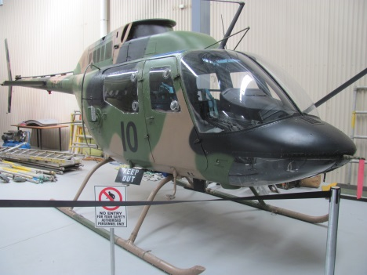

**History of Type**

The Bell OH-58 Kiowa was developed from the Bell 206 civil helicopter as a light observation helicopter for the United States Army, with first deliveries in May 1968, and a total of 2,200 produced.

By the end of the 1960s, it was clear that the Australian Army’s Bell 47G Sioux helicopters were no longer suitable for the battlefield observation role. In late 1971 eight Bell OH-58A Kiowa helicopters were leased by the Australian Army for service in Vietnam as an interim measure. An order for 75 OH-58A Kiowas was placed with Bell during 1971, with all but the first 12 to be built by CAC in Melbourne – this order was subsequently reduced to 56.

The Kiowa was used by the Army as a light observation helicopter and served with 161 and 162 Squadrons of the 1st Aviation Regiment in the battlefield reconnaissance role until 2007 when it began to be replaced by the Tiger Armed Reconnaissance Helicopter in 2007.

The Kiowa has also been used in the training role and around 20 Kiowas remain in Australian Army service at the Australian Army Aviation Training Centre, these being scheduled for retirement in 2019 once the new joint (Army and Navy) helicopter training program commences.

**Technical Specifications**

**Engine :** 1 x 313kW Allison T63-A-720 turboshaft driving 2 blade main and tail rotors

**Maximum Take-off Weight :** 1360kg

**Length :** Fuselage length9.84m – overall length with rotors turning 12.49m

**Main Rotor Disc Diameter :** 10.77m

**Height :** 2.91m

**Cruising Speed :** Max at sea level 196km/h, economical cruise – 102km/h

**Ceiling :** 19,000ft

**Range :** 480km

**Crew :** 1 pilot and observer

**Capacity :** Pilot, observer and up to 3 passengers