Let **Aero 145 C/n 20-002**

Four/five seat light utility twin engine aircraft.

**History of VH-WWC**

Aero 145 VH-WWC was manufactured at Kunovice Czechoslovakia by Orlikan (Czech Aircraft Works) in 1961/62, then crated and shipped to Dulminson (Australia) P/L, Bankstown NSW.

On arrival it was reassembled and prepared for sale.

In mid-1962, John Doudy of Commodore Aviation Port Lincoln had successfully negotiated an extension to his contract with SAFCOL Tuna Processing Co for aerial fish spotting for the Port Lincoln fleet. Having used a Republic RC-3 SeaBee amphibian aircraft for the previous season, John found that performance limitations restricted his ability to cover as much area as required under the contract. So John was on the hunt for a replacement. The Aero had come to his notice, he successfully negotiated a sale, in October 1962, including the trade-in of the SeaBee, enabling him to service the later part of that years NSW tuna season.

John then returned to Port Lincoln on December 1st. In preparation for the upcoming 1963 tuna season, he conducted several survey flights, finding fish on the 15th of December, this catch opened the season, which normally would not have occurred until the end of January. With the use of aerial spotting, catches steadily grew over the next few years.

The aircraft continued to operate with fishing spotting duties (both tuna and salmon), replenishing supplies for the lighthouse operators on Althorpe and Neptune Islands. Along with general charter duties, aerial searches for missing fishing craft, and providing access to the many other islands up and down the west coast until 1979 where she was placed in storage and deregistered.

In 1985 John Ellis and David Harris purchased VH-WWC along with DUH , WWH and spares with the view of restoring the aircraft to flying condition. WWC was then reregistered as VH-ZCL.

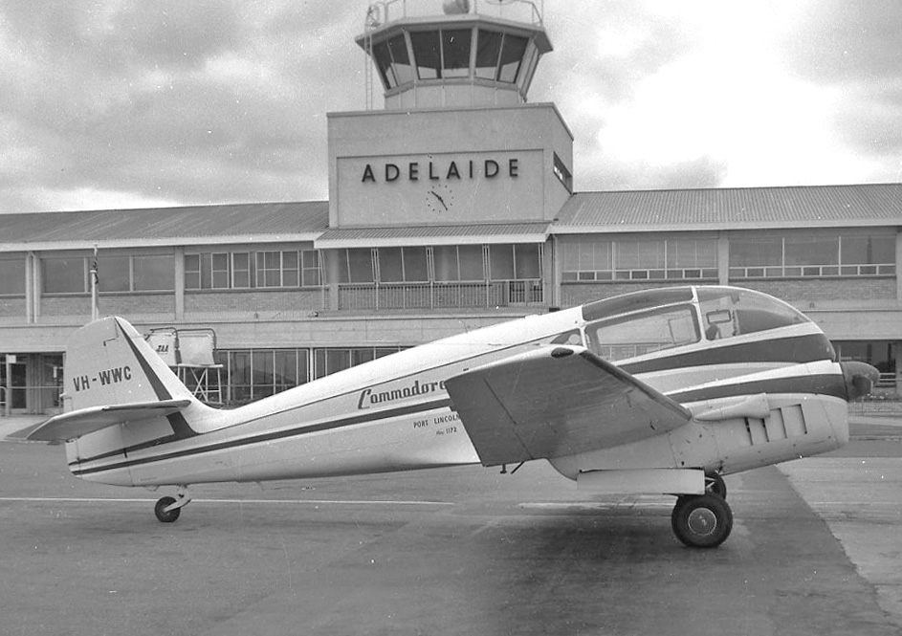

**History of type**

At the end of WW2, a team of five Aero company employees, in secrecy, began design work, on the Aero 45. When management eventually became aware of the design potential, a go ahead to produce a prototype was given.

The aircraft featured an all-metal semi monocoque fuselage, a two spa cantilever wings and fabric control surfaces. Featuring electrically operated retractable undercarriage, split flaps and propeller pitch controls. Powered by twin Walter Minor 105hp inline four cylinders, fuel injected engines.

The prototype flew for the first time on 21st July 1947. Delivery of the first production aircraft occurred two years later. 428 aircraft were delivered before the upgraded Aero 145, manufactured by Let, was introduced in 1959. This model had improved aerodynamics, was powered by twin Walter Minor M332 140hp, supercharged, 4 cylinder, inline, air-cooled, fuel injected motors. Other improvements added, were a bulged canopy for improved cabin comfort and upgraded instrument panel.

Of the 162 Aero 145’s produced by Let, four were imported into Australia along with one Super Aero 45.

Super Aero 45 VH-WWH

Aero 145 VH-DUA, DUB, DUH and WWC.

The Aero over a period of ten year, proved to be the ideal type of aircraft for providing reliable, safe and efficient service for accessing the remote rugged bush airstrips of Neptune and Althorpe Islands south of Port Lincoln.

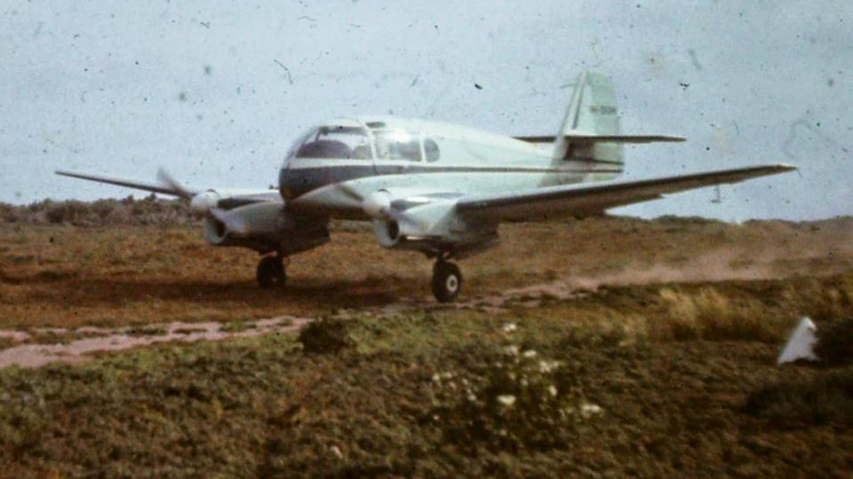

**Technical Specifications**

**Engines:** Walter Minor M332 104KW (140hp) 4 cylinder, fuel injected, air cooled, supercharged, fitted withtwin blade electrically adjusted pitch propellers

**Maximum take of weight:** 1600 kg. (3527 lbs)

**Maximum speed:** 152 knots. (282km/h)

**Range:** 1700 km. (1055 miles)

**Ceiling:** 5900 m. (19360 ft)

**Length:** 7.80 m (25 ft 6 in)

**Width:** 12.30 m ( 46 ft 2 in)

**Height:** 2.30 m (7ft 6 in)

**Capacity:** 1 pilot and 3 or 4 passengers.

**Useful load:** 600 kg.