**Aero 145**

**Aero 145 VH-WWC / ZCL**

Twin Engine 4–5 seat Utility Aircraft

**History of VH-WWC / ZCL**

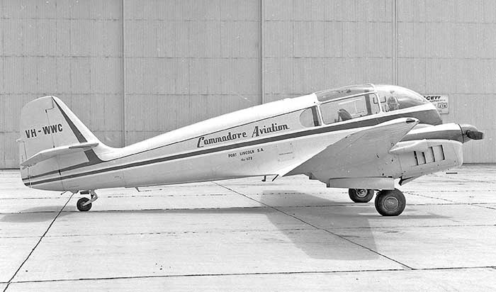

Aero 145 VH-WWC / ZCL was built at Kunovice, Czechoslovakia in 1961 and was imported into Australia in 1962, being assembled at Bankstown by Australian agents Dulmison in October 1962.

Commodore Aviation Pty ltd was set up by John Doudy and his wife Rosemary (parents of SAAM volunteer Chris Doudy) to carry out fish spotting services, in particular tuna spotting; it was based in Port Lincoln. A Republic RC-3 Seabee amphibian was acquired and spotting commenced in April 1961. A single engine and relatively short range limited the effectiveness of the Seabee and John undertook research for a more suitable aircraft.

The Aero 145 available from Dulmison came to his notice. Being a light, versatile twin engine utility aircraft, with a large fuel capacity giving an approximate 1,700km range, great downward visibility and good engine-out performance, the aircraft met all requirements for spotting.

The Seabee was traded on VH-WWC, which was painted in a blue and white colour scheme with the wording ‘Commodore Aviation Port Lincoln SA’ painted on the fuselage – the above photograph shows the Aero 145 at Bankstown prior to delivery to John, who immediately flew down to Eden, enabling him to complete the NSW season before returning to Port Lincoln.

Departing Port Lincoln Airport, the aircraft would cover an area from Kangaroo Island out to the Continental shelf (approximately. 200 kms from Port Lincoln) to the Great Australian Bight. They were capable of staying aloft for up to 10 hours. Over the next few years catches increased in what were the boom times for the industry.

Powered by powerful supercharged engines combined with large flaps, the Aero had outstanding STOL capabilities making it an ideal aircraft for accessing the likes of Neptune and Althorpe Islands. John approached the Department of Transport about providing a regular supply service to lighthouse keepers. A contract was awarded in October 1963 with this service continuing for ten years without any major incident. The Aero 145 also flew into St. Frances and Evans islands off Ceduna, Cape Bauer, Flinders and Pearson islands to service the unmanned lighthouses under the same contract. Commodore was able to provide easy access to Reevesby, Spilsby, Wedge and Thistle islands for their owners as required.

Following the acquisition of a Cessna 337 for fish spotting in 1968, VH-WWC (and companion aircraft VH-DUH) continued with charter and island service work until withdrawal from service in around 1979, and were put into storage.

John Ellis and David Harris bought VH-WWC in 1985 and the airframe, by then removed from the Register as ‘withdrawn from service’, was loaned to the, then, SA Historical Aviation Museum in Port Adelaide. It was moved to Parafield in 2001 as a long term restoration project and restored to the Register as VH-ZCL, owned by the ‘Charlie Zulu Lima’ Trust. It has since been relocated to Pallamana airfield, Murray Bridge

John and Marj Ellis and the ‘Charlie Zululima Trust’ have donated VH-ZCL to SAAM. The aircraft has been dismantled for restoration and SAAM will undertake the restoration and display the aircraft in due course.

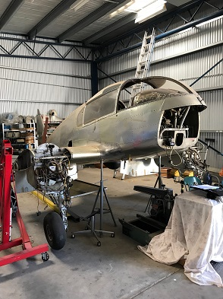

**History of Type**

The Aero 145 was the final version of a range of 4 to 5 seat twin engine utility aircraft designed by the Czechoslovakian Aero company, with design and development beginning in 1946. The prototype Aero 45first flew in July 1947 and production commenced in 1948.

The Aero 45 was a low wing twin all-metal design with retractable undercarriage powered by two 105hp Walter Minor engines driving two blade propellers. Between 1948 and 1951 200 Aero 45s were produced. An improved version – the Aero 45S or ‘Super Aero’ - with improved navigational equipment was developed and 228 of these were built from 1954 to 1959 by the Let company.

The Aero 145 was further refined and had more powerful 140hp (104KW) fuel injected Walter Minor M322 engines with variable pitch propellers. Let produced 162 Aero 145 aircraft between 1959 and 1963.

The Aero 45 / 145 family of aircraft were popular because of their speed and range and their adaptability, and were used by both civil and military operators as utility, communications, training, air taxi and leisure roles.

One Aero 45 and four Aero 145s were imported into Australia.

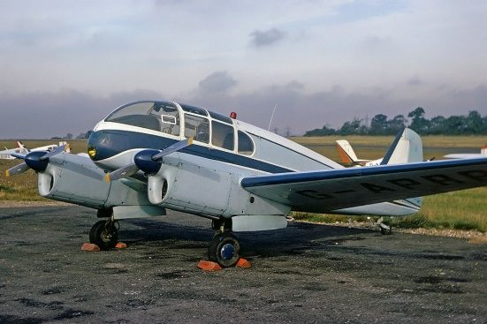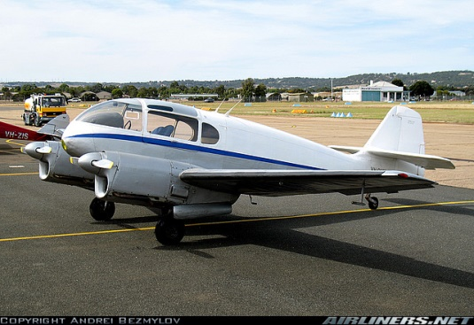

*Aero 45 (left) Aero 145 (righ)*

**Technical Specifications (Aero 145)**

**Engine :** 2 x 104kW (140hp) Walter Minor M322 fuel injected, supercharged, air cooled

engines with two blade electrically operated variable pitch propellers

**Maximum Take-off Weight :** 1600kg (3527lbs)

**Length :** 7.8m (25ft 6in)

**Wingspan :** 12.3m (46ft 2in)

**Height :** 2.3m (7ft 6in)

**Speed :** Cruise - 135 knots (250km/h); Maximum – 152 knots (282km/h)

**Ceiling :** 5,900m (19,360ft)

**Capacity :** 1 pilot and 3 / 4 passengers, 600kg useful load

**Range :** 1,700 km (1,055 miles)

